Assignment 8.1

1. When to use (Rapid Application Development) RAD model. When not to use (Rapid Application Development) RAD model.
Ans: RAD model can be used when :
- there is a need to create a system that can be modularized to be delivered in incremental manner
- use of automated code generation tools fits into the project budget
- highly skilled resources are available and budget should also allow to involve highly skilled resources as they need to be paid more
- there is a need to produce the system in a short span of time (2-3 months)
- there is high availability of designers for modeling
- the requirement changes can be accommodated easily

RAD model is not appropriate to use when :
- unavailability of skilled or technically strong people within the organization
- there is no need of system modularization
- budget of the project is less as the automated tools and the skilled resources need high budget
- the customer is not oftenly available for the project involvement
- the project is big and needs a longer development time
- the project requirements does not encourage high management complexity

2. Define an ER diagram of a software Organization with all the relationship model that was discussed in the classroom.
Ans:
Employee
Name
Age
e_ID
Address
Mob_No
Sex
DOB
Department
d_name
d_ID

works_for

controls
works_on

Project
p_name
pno
Client
c_name
c_ID
request

3. Describe the Entity Relationships for the following diagram

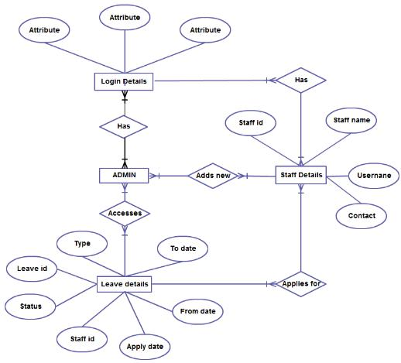

Ans : Deifferent entities are :
- Login Details
- Admin
- Staff Details
- Leave Details

Relationship between login details and admin
- According to given notation there exists many to many relationship between login details and admin
- However, ideally there should be one to many relationship between the two entities because all admin have the login details but one login detail should be associated with one admin only.

Relationship between login details and admin
- According to given notation there exists many to many relationship between login details and staff details
- However, ideally there should be one to many relationship between the two entities because all staff member should have the login details but one login detail should be associated with one staff member only.

Relationship between admin and staff details
- According to given notation there exists many to many relationship between login details and staff details
- However, ideally there should be one to many relationship between the two entities because an admin can have many number of staff member working under him but one staff member can be associated with only one admin at a time.

Relationship between staff details and leave details
- According to given notation there exists many to many relationship between login details and staff details
- However, ideally there should be many to one relationship between the two entities because many staff members can apply for the leave and thus leave details can contain details of many members but one leave will associated with one staff member only.

Relationship between admin and leave details
- According to given notation there exists many to many relationship between login details and staff details
- However, ideally there should be many to many relationship between the two entities because all leave details can be accessed by all the admins and also the single leave detail can be accessed by many admins .

